Design Document – Digital Scripting

**3D Walking Simulator Puzzle Game inspired by *The Witness.***

Players wake up on a beach, and they are presented with a ‘cutscene’ of the character waking up, confused. They take out a map of the island with some words on the back reading “We, the Island Spirits, noticed that you are stranded on this island with a broken boat. We will help you if you return the favour of completing our puzzles”. After that is the first riddle for the first puzzle.

When players complete a puzzle they will receive a riddle for the next puzzle and a part of their boat.

The puzzles:

* Players have to find two rocks which look identical that fit into the hole in one of the islands totems. This uses a pickup mechanic (right now I’m trying to figure out how to rotate the objects the player grabs). Below is my code that I have got so far for the pick ups.

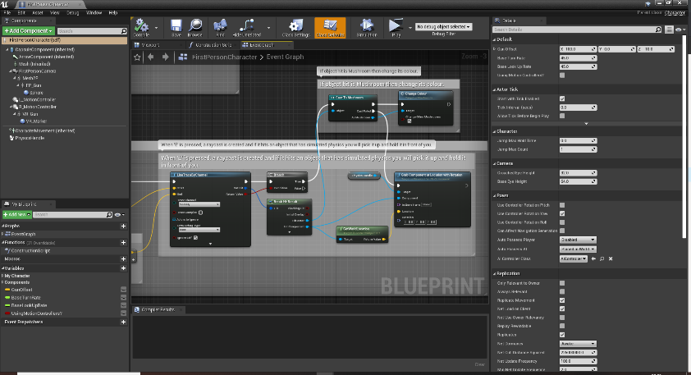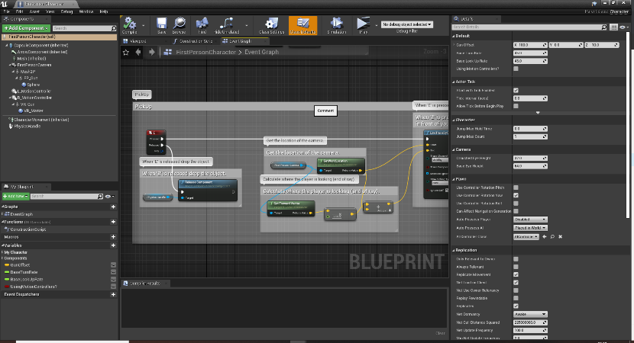The riddle for this puzzle is : “Pick me up and place me in, I might even have a twin”.

* Players have to change all the glowing mushrooms to blue. When players press E on one mushroom, it changes the colour of the mushroom they clicked and two other mushrooms. This uses raytracing and emissive materials. (Below is my code for the mushrooms).

The riddle for this puzzle is: “We are more colourful than at first sight, find out by giving me a fright”.

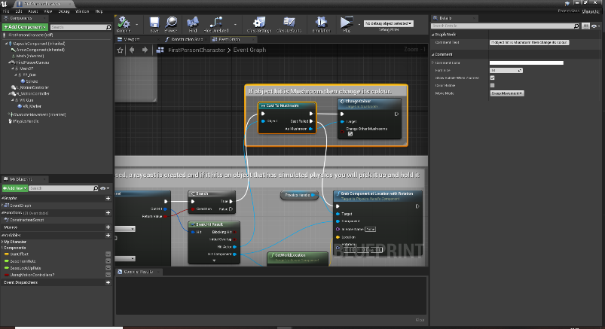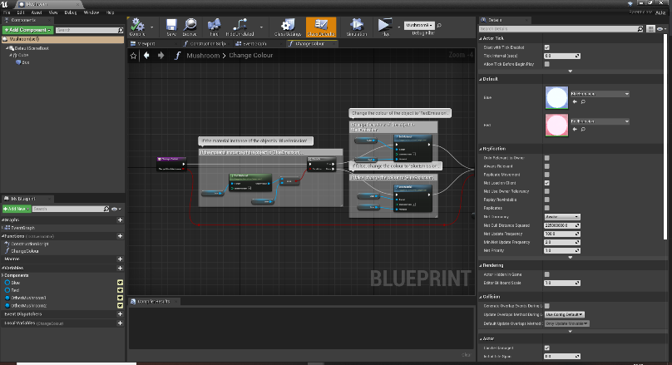

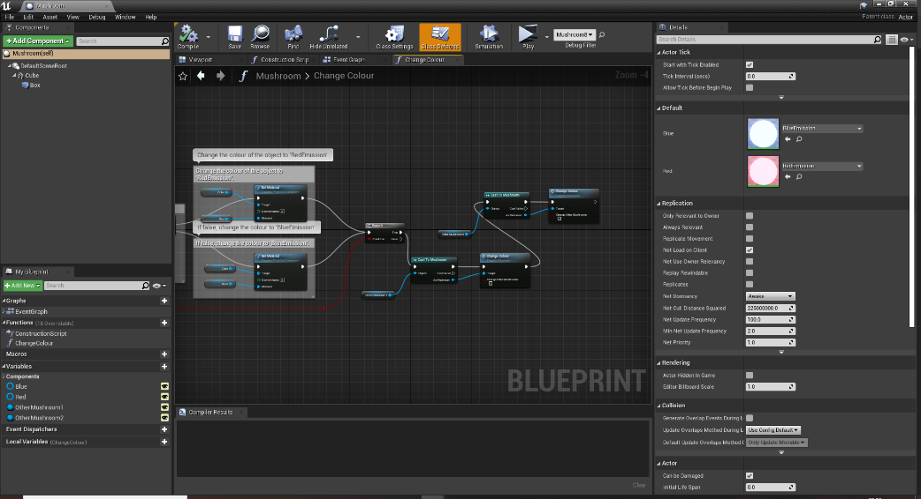

* Within the previous puzzle players will be given a bag of seed (or maybe they have to find it, I’m not sure). Players will have to throw seeds at a group of birds which will make them sing a tune. Players will then have to memorise this tune in order to figure out the puzzle. A lock will be located on a small building which the players have to open using the tune the birds sang. Each button will make a different chirp/sound. The seeds throwing can be a form of a projectile mechanics or a ‘grenade like’ mechanic, along with the use sounds.

The riddle for this puzzle is: “You’ll find them sitting in a ring, when thrown a seed they will sing”.

* Players will have to use the light of the lighthouse make the island spirit statue glow gold. Players have to direct the light into a hole in the top of the cave. In the cave is a series of mirrors. The light has to bounce of the mirrors to get to the back of the cave where the island statue is. This will be the final puzzle.

The riddle for this puzzle is: “Long ago I shone so bright, help me glow by shining light”.

Also situated around the island will be small ‘easter eggs’ (If I get time to include them). They will be different looking island spirits and when ‘interact’ with them they play a funky tribal sound.

The game will start off at sunset and as time progresses/ after each puzzle has been completed, the sky will slowly turn to night which can create a wonder/awe emotion from the glowing of the mushrooms and then lighthouse.